

**The Dangers of going out Alone: Are women really aware of the risk?**

**By Emily Burke, Lyla Muhuhu and Autumn Smith**

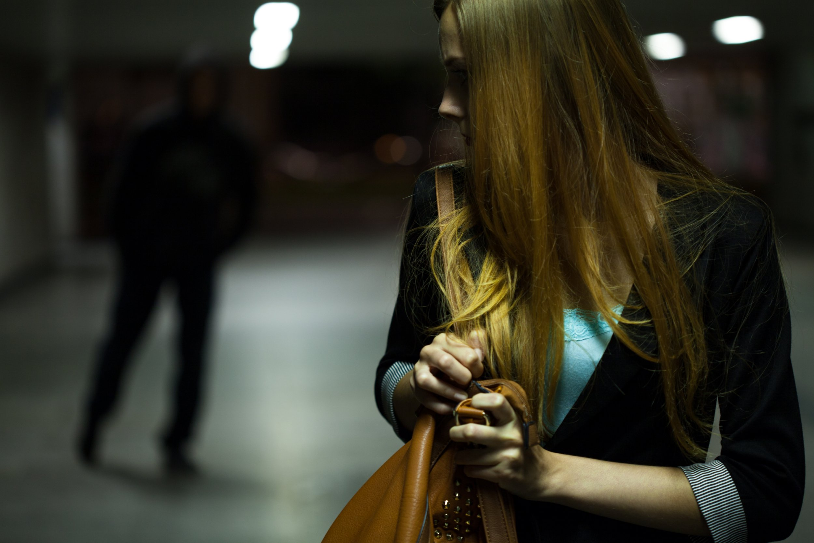***New data shows extent to which women feel unsafe at night***

Data released in 2021 reveals that:

* - One in two women feel unsafe walking alone after dark in a quiet street near their home (compared to one in seven men)
* -One in two women feel unsafe walking alone after dark in a busy public place (compared to one in five men)
* -Two out of three women between the aged of 16-34 experience one form of harassment within the previous year

_____________________________________________________________

Data from 2021/22 reveals a large increase in violence against women, with most of it being intimate partner violence. This can negatively affect women's physical, mental, sexual and reproductive health and may increase the risk of acquiring HIV in some settings. The W.H.O. (World Health Organisation) states that violence against women is preventable, but how?

Our reporters have interviewed Hong Kong Police officer, Jackie Chan. He was asked how the police force prevents women from being in threat. To this he answered, ‘the enforcement team shall be strategically deployed to those locations where the sexual crimes happened frequently as highly-visible patrol, which was believed to act as the deterrent effect to those potential culprits.’ The Hong Kong Police team advise members of the public to plan a safe route to the destination, to ensure someone else knows their plans and keep alert. Seeing Hong Kong is ranked the 5th highest safety factor in the world- with one of the lowest crime figures, women are advised to walk alone at night as long as they have self-awareness.

The impact of violence against women contains both social and economic value. The cost of intimate partner and sexual violence are enormous and have a ripple effect on society. Through this, women may suffer isolation, inability to work, lack of participation (in regular activities), loss of wages and a limited ability to care for themselves and children. Affecting not only the individual but others around them.

_____________________________________________________________

**Response and Prevention**

In 2019, the UN Women and W.H.O. (along with 12 other UN and biliteral agenises) pushed for *RESPECT* for women. Over the coming years, there has been growing evidence on what works to prevent violence against women, based on well-designed evaluations.

Each letter from the *RESPECT* campaign stands for: **R**elationship skills strengthening, **E**mpowerment of women, **S**ervices ensured, **P**overty reduced, **E**nabling environments, **C**hild and adolescent abuse prevented, **T**ransformed attitudes, beliefs and norms.

The meanings behind the *RESPECT* scheme highlight the importance of the awareness of women's safety. Seeing as gender-based violence was already a global crisis before the outbreak of COVID-19, the W.H.O. has launched *RESPECT* inthe hope to achieve lasting change and solve the problem to this crisis.

The W.H.O. implies to achieve long lasting change, tEhe following need to be implemented:

* To enact and enforce legislation
* To develop and implement policies that promote gender equality
* Invest in women's rights organisations
* Allocate resources to prevention and response

_____________________________________________________________

**Alternative responses**

[Women's safety: 'Whatever precautions women take, is it going to be enough?'](https://youtu.be/RzbeqjZIK4I)

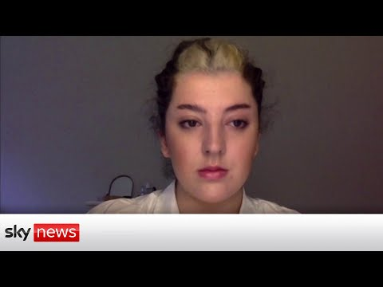

*“Women can’t seem to do something as simple as walk home without the risk of harassment, attack, murder”*

**Alice Jackson: Co-founder of Strut Safe has been interviewed by Sky News on the precautions taken regarding the safety of women.**

Strut Safe was founded by Alice Jackson and Rachel Chung following the murder of Sarah Everard in March 2021. They felt as though there was a lack of laws and preventions initiated by the government therefore, they set off to find a solution to this problem as the younger generation. They were “reminded that there is much work to be done to dismantle systemic violence against women and other marginalised groups”. Strut Safe is an initiative to help anyone who feels unsafe when walking in public. This is run by volunteers based across the U.K. who are ready to take calls at almost any time and will stay online with you until you reach your door.

_____________________________________________________________