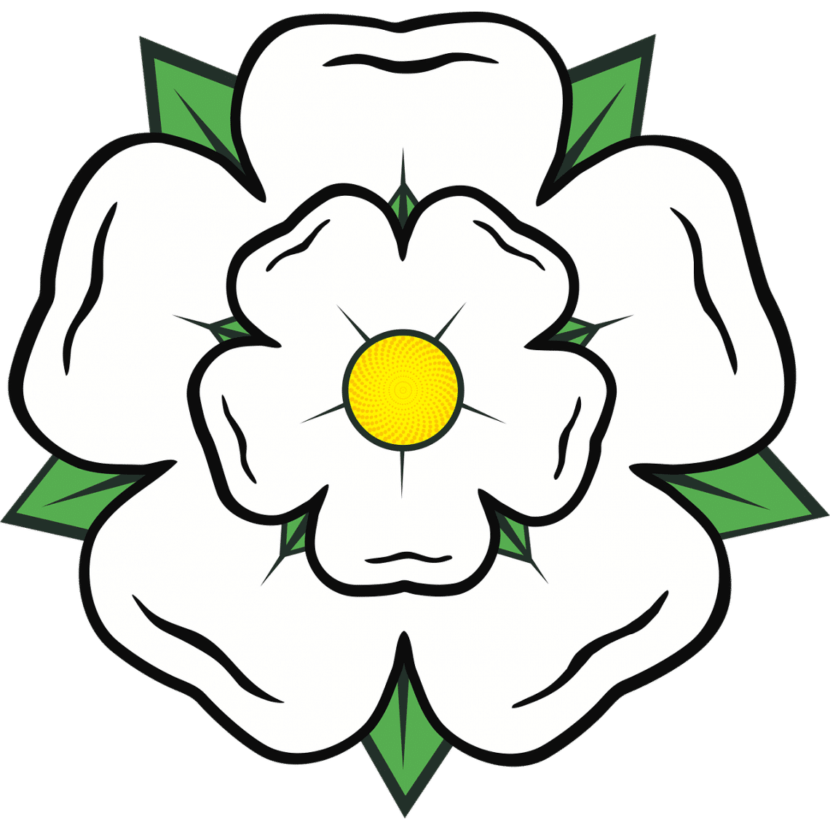H**ARROGATE HECTIC HEADLINES**

7/03/2020 By Amelie Coyle, Chloe Homer, Maisy Lindley and Hattie Dixon

There have been and still are many Housing Development plans across Harrogate. Two examples are, in Harlow Carr and now down Penny Pot Lane. Did you know in 2017 a plan to build 3000 houses in between Harrogate and York was approved by Harrogate Borough Council? Campaigners said that this approval was ‘utterly devastating’.

**Raising Roofs – Harrogate housing development gone overboard?**

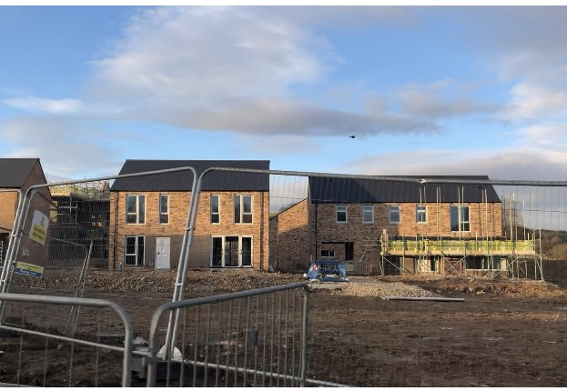



This image is of a housing development area on Skipton Road. We took this phot on our way to school and it really slows the journey down.

**-who are they?**

We don’t want this happening all around the area of Harrogate. However, there are positives and negatives to new housing developments in Harrogate.

Taylor Wimpey state on their website ‘We are one of the UK's largest residential developers. As a responsible developer we are committed to working with local people and communities.’ So, we contacted them because they said they were committed to working with local people and communities. We sent an email five days ago and they have still not yet responded. We previously contacted Harrogate Borough Council and Kingsley smith Solicitors as they said they were open to questions, still, no response. Then Kingsley Smith Solicitors said that we could ask a free legal question on their website, but no one responded. It seemed they were reluctant to answer our questions, all three people. We have come to the conclusion that if Taylor Wimpey wouldn’t respond to our email, they are not committed to working with local people and so have lied on their website. Taylor Wimpey created the housing development in Harlow Carr. We hope they move in the right direction and stop building so many houses.

If we take up more and more of the environment with houses, what is that doing to help the crisis we have put our planet in. Global warming is bad enough shouldn’t we be mindful of how much green space we take up? Harrogate is already such a beautiful and lovely place because of the nature all around. Even in the centre of town there are trees and flowers all over. You don’t normally get this in the middle of a town and it is probably a strong contributor to being the happiest place in Britain for three years (2011-2013). Having more houses will bring lots more people in to Harrogate and more people means more cars and vehicles that pollute. Cars produce carbon dioxide and carbon monoxide which are both toxic gases and greenhouse gases which add to global warming. Yes, this is a small contributor to global warming and there are bigger problems, but more houses mean more people, which means more cars, which means more greenhouse gases and pollution, which damages the environment. So, if we stop building so many houses in Harrogate it will be a very small step towards saving the environment because then other towns will stop too and will turn a small step into a big one.

here is the simple fact that we need more houses to home people. The estimated population of Harrogate is around 75,070, that is a lot of people to create houses for. Harrogate was voted the happiest place in Britain for three consecutive years so this could attract more people, increasing our need of houses. We also have around 130 homeless people in Harrogate and 1 in 1202 people are homeless here. This is a disappointing figure but compared to the 75,070 total population of the town it is a relatively small number. Also, 122 of these people live in temporary housing and Harrogate Borough Council provides advice and help. Therefore, this actually proves that we don’t need any more housing developments because only 130 people are homeless and building more houses is not going to help these people find homes because they won’t be able to afford them anyway. So, who are these houses meant to help? It would be better if they made more affordable houses or none at all. Did you know that more housing developments around Harrogate will cause congestion and increase flooding because the drainage will decrease? It will also take up green space and harm the environment.

Firstly, a positive to building housing estates

Harrogate Borough Council crest.