Furious Feminists in Mexico

What is feminism?
Feminism is the belief that all sexes should be equal. There have been many protests to make this happen because women feel like they are mistreated because of their sex.
Mexico
In Mexico women feel like they are being treated differently and feel less important than men around society. These protests have been taking place in the centre of Mexico City. More than 10,000 women attend and make themselves heard by painting the streets, holding up posters, offering tributes or even singing! A year ago, there was a huge protest in the ‘zocalo’ in Mexico City. Woman were feeling angry and like they were not being heard, so they felt the need to do something big to protest. They attempted this by painting the streets and putting graffiti all over the most important monument in Mexico City ‘El Angel de la Independencia’. This made most people angry, arguing that they should not damage such important monuments, while some argued that they had to do it because they were not being heard. In our opinion, a monument should not be more valuable than a woman’s life.

Our Interviews
We interviewed two important Mexican actors’ called Erendira Ybarra and Regina Blandon who gave us their point of view regarding feminism. They both agreed that a change needs to be made. Since they both have people who admire them all around the world, they are using social media to pass on the message and let people know everything that is happening.

Victims
In Mexico, 10 women are murdered everyday and most of them are also sexually abused. Since the government is failing to provide concrete solutions, women have started to rise up about this issue; since 2019, out of 3,892 women that were abused and killed only 613 cases were investigated. On the 12th of February it was reported that a seven-year old girl, Fatima, had gone missing. She was found dead 4 days later, with signs that she had been raped and tortured. This was not the only thing that made Mexicans angry, it was the fact that there was nothing being done to help or prevent this occurrence. Fatima was not the only case ever reported, she was one of the ten women who are being tortured and killed every day. Days after this case was reported, more protests started happening. Women were so incensed that their protests took a violent turn, vandalising many areas. They raised posters to highlight individual cases, with pictures of all who had lost their lives because of this violence.
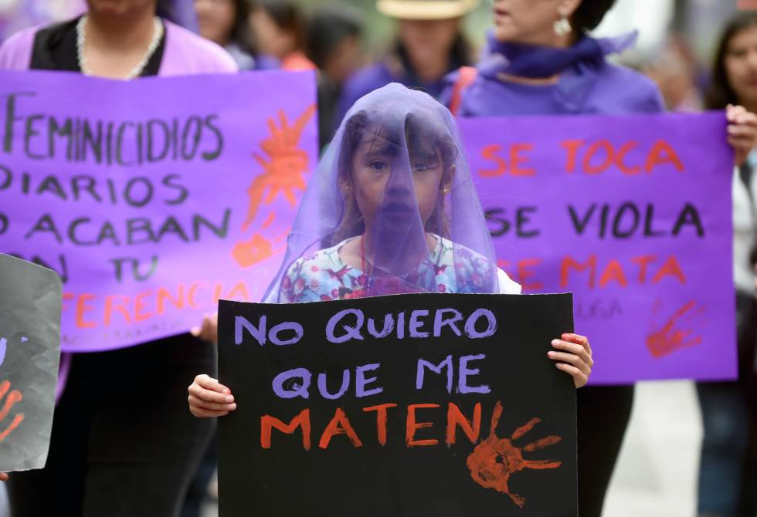
Social media
Thanks to social media, there has been a lot done to pass on the message and work towards helping these families who lost their mothers, daughters or even just suffered abuse. The campaign ‘El dia despues’ started to ask famous people to pass on the message by showing what was really happening on their social media. This has helped make everyone aware of what is happening and what we can do to help or to protect ourselves.

How to be safe?
With everything that is now happening, women are scared to go out of their homes or even stand up to someone who is making them feel inadequate. People have come up with new ideas to feel safe and not be in danger all the time. These are;
- If you feel uncomfortable with a man at work, school, etc. report it immediately with someone you trust.
- If you are walking alone to your house and someone is following you, you should shout as loud as you can to make people know you need help.
These are just some rules that have been made so women can feel safe. The rules apply to what is happening in Mexico right now.

