Plastic Planet
By Emily, Olivia, Freya, Greta and Megan

Introduction
Plastic is everywhere on our planet; it has been for several decades. Plastic is an integral part of society and is used everywhere.
Although plastic could be one of the best inventions ever, we don’t know how to deal with it properly. Therefore, it has become a huge ongoing problem that the whole world needs to come together to help solve.

Statistics
- Every year, 8 million tons of plastic gets dumped into the ocean
- Every year 100 million marine wildlife species are killed because of this.
- The plastic can either hurt or trap these creatures as it can be mistaken for food.
- Plastic is found in 90% of dead sea birds and 100% of dead turtle species as they mistake thing like plastic bags for jellyfish.
- Many animals starve because of stomachs which are full of plastic rubbish that cannot be digested.

News
It’s not just marine wildlife that suffers. An endangered red squirrel was found by a busy roadside stuck inside a plastic jar. The poor animal had suffered a very painful death as it had found the jar, tried to get the food remains out from inside, and cut its throat whilst trying to pull itself back out.
In 2018, a dead sperm whale washed up in Spain. He had eaten 30 kilos of plastic bags, nets and even a drum.
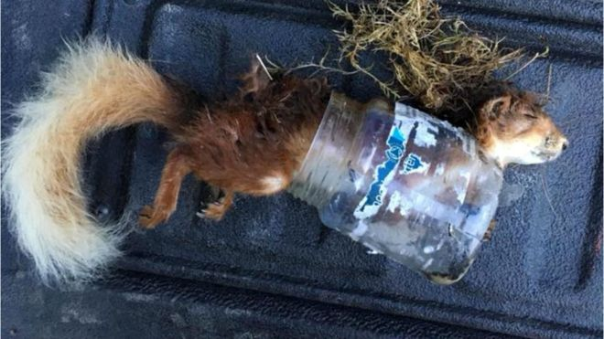
Both the red squirrel and sperm whale are tragic incidents which demonstrate exactly what can happen if the world carries on how it is. Incidents such as this can cause more and more animal species to become endangered.

Grampian Moorland Group/Deadline News
BBC NEWS

Who is to blame for plastic waste in the first place?
Members of the public are most likely to blame companies, supermarkets, businesses and the government for these issues. However, we shouldn’t jump to any conclusions as we impact very heavily on the situation.

What can we do about it?
Supermarkets and other companies need to cut back on the amount of plastic packaging they use when selling products. Part of the problem is what we consumers are doing with the plastic we buy.
We need to try and stop buying the items in shops that are heavily wrapped in plastic. I know that it’s not as simple as that, because sometimes you just can’t buy items without packaging or items such as fruit and veg are a lot cheaper and fresher when wrapped in plastic. All we’re asking is that you try.

How is HLC contributing?
We’re always trying to think of new ways that we can help our planet, such as providing more recycling bins across the whole school and making sure that people are aware what can be put inside them and where they are.
The school has banned single-use plastic cups and plastic water bottles in packed lunches. Everyone now has to bring in their own reusable water bottle from home.
We are trying to use some good alternatives for plastic such as paper, recyclable glass and biodegradable plastics which are plastics that can be decomposed by the action of living organisms.

What is being done outside school?
Some shops are planning on extending the 5p plastic bag tax and the government are proposing to put a 25p tax on disposable coffee cups.
Places such as MacDonald’s and Starbucks will be getting rid of plastic straws and replacing them with paper ones.

Conclusion
We have explained the importance of saving our planet and the urgency of this. We need to change the ways that we live and do things, or else the problem will turn into a disaster that we won’t be able to fix.
